Ecole Intermédiaire Lawrence Grassi Middle School Council
Meeting/Staff Room LGMS
MINUTES OF MEETING
Date: Thursday, January 15, 2015
Attendees: Adrienne Lawlor (Chair), Dana Williamson (Treasurer), Kat Wiebe (Communications Coordinator), Nadine Trottier (Ass’t Principal), Brian Wityshyn (Principal), Terri Solodan, Cheryl Godefroy, Rhona Griffin, Simon Orrell (Members at Large), Leanne McKeown (Trustee), Heather Wilz, Mary-Lou Adams
Regrets: Michelle Kiist (Vice Chair), Betty Mah (Volunteer Coordinator)
Item |  | Action
1 | Call to order | 6:30 (Cheryl)
2 | Adoption (amendment) of Agenda  Leanne McKeown requests that LGMS PC discuss any issues/concerns to forward to next Trustees mtg Jan. 28: added to roundtable discussion | 1^{s} Terri 2nd Rhona
3 | Confirmation/Approval of Past Minutes | Dec. Minutes approved. (Terri, 2nd Dana)
 | DPA: Brian will inventory DPA equipment
4 | Regular Updates
4a | Treasurer’s Report: Motion to adjust budget line for Welcome package from $84 to $25 | 1st Terri, 2nd Adrienne
4b | Principal’s Report: will be attached to minutes | No Action required
4C | Communication Education Network: 3-year calendar update: feedback received from PC and parents, answers are being compiled, draft versions will be presented for feedback; school board will vote to create final version in March | No Action required
4d | Rotary Grant: Cheryl Godefroy signed agreement for PC (this includes agreeing to display AB Winter Games logo on any equipment purchased, and to follow up within 12 months of receiving money); Motion was made to accept Cheryl Godefroy’s signature on behalf of Lawrence Grassi Middle School Parent Council (signature page attached); Cheryl will attend Rotary breakfast Feb. 4 at Canmore Golf and Curling Club to receive cheque; original request was for $30,000 (x-country ski equipment, heartrate monitors, bicycles, shelter) and received $6500—what to purchase?? discussion with LGMS Phys. Ed. teacher needed to determine priorities and ideal numbers and when to purchase; discussion occurred about purchasing heart rate monitors to encourage all students to monitor their personal best (again, discussion with Andrea required); PC agreed to include theme of heart rate monitors vis-à-vis encouraging students’ personal best in strategic plan and to ask for teacher PD to support students’ personal best as foundational piece of physical literacy; motion made to support gym teacher to decide how to spend money | 1st Rhona, 2nd Adrienne  1st Rhona, 2nd Terri
5. New Items
5a | Project request form: anyone requesting money from PC must fill one out; Adrienne will update and send electronic copy for future use
5B | Request for funds $500 for WordSmash: PC asked for more information on event, and what is $500 for? (fill out project request form) Kat will take this to event organizer
5c | Learning the digital language of teens: Adrienne proposed that PC continue to educate ourselves and other parents about teens and technology; PC agreed that this is important, to know what Aps students are using, what is content, how socializing is facilitated, and what are risks; Adrienne provide link to article (worst Aps); PC requested this topic be kept agenda to discuss screens/aps/technology; PC members are encouraged to post links and articles/info of interest on LGMS Facebook page
6 | Business Arising from Past Minutes
6b | Graduation Dance: Mary Lou Adams and Mary Anne Wasch offer to host grad dance--what is best date for that? Brian says it’s usually held on second last Thursday of June—with informal farewell ceremony at 7 pm and doors open for grade 7s at 8, and dance 8 – 10 pm; discussion occurred about details (half gym, Rob Murray DJ, coordination of volunteers, rules (once you leave you can’t get back in), grade 8s bring snacks, grade 7s bring drinks; food in gathering area, staff member will stay until end so monitor is not needed, cost of DJ covered by $5 per person collected by parent volunteer at door
6a | 3-year strategic plan: Cheryl says current plan is good; process to update it is simple (see graphic): go through vision and mission and agree on it, and do needs assessment (what do teachers need from parents); discussion occurred about what is process to facilitate this communication--Brian mentions teachers’ wish list: (TTFM survey could include this question): Cheryl encourages all to think ahead, school will be 12 years old soon; other ideas include what are needs for zones of regulation and emerging technology (eg: stand-up desks); discussion about balancing a school-driven wish list with Council-supported higher level view of parent and student engagement and shaping school culture; how can council best support inquiry based learning, given upcoming curriculum update and whole-child learning? | Action: Read current three-year plan, familiarize ourselves; think about how we each can participate in this discussion  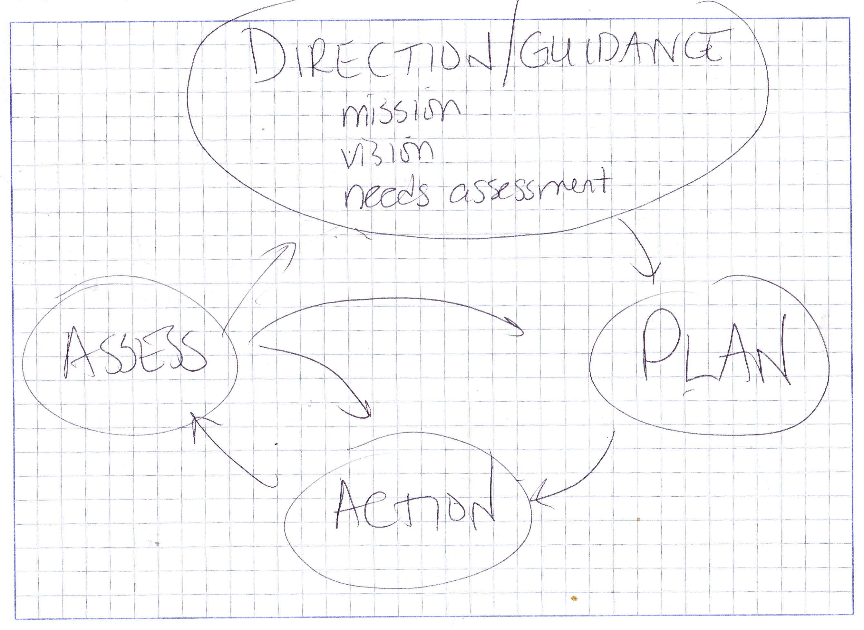
6c | Board of Trustees looking for PC rep to attend upcoming meeting to bring school-specific concerns, requests, themes, questions, etc, so Trustees can prioritize before heading into budget conversations; Adrienne suggests all council members send issues and/or questions to her and she will be spokesperson | send issues and/or questions to Adrienne before Jan. 28 meeting
 |  | Motion to adjourn: Kat
7 | Next Meeting: Feb. 5 @ 6:30

